**Customize Rspec Report Instruction**

In this document, we will instruct how to customize the rspec html report by inheriting ‘**RSpec::Core::Formatters::BaseTextFormatter’** class and override some methods to generate a new Rspec report template as expected.

1. /***rails_app/*** ***automations/lib***

* **lf_html_formatter.rb**: define a ‘LFHtmlFormatter’ class that inherited from “BaseTextFormatter” class of Rspec lib, use to get and format result info then display them to html_printer
* **lf_html_printer.rb**: use to show html mock-up
* **lf_snippet_extractor.rb**: use to show fail debug in report

1. We can customize all report templates by inheriting the ‘BaseTextFormatter’ class; override some methods and editing html template in “lf_html_printer” file.

**Default report:**

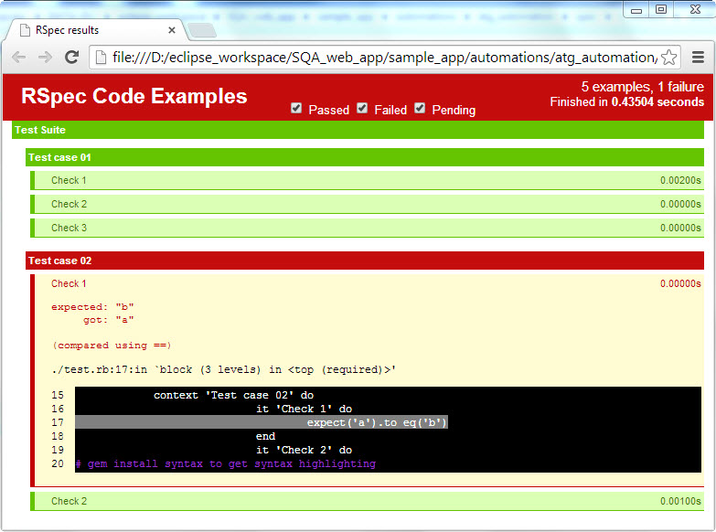

**Customized report:**

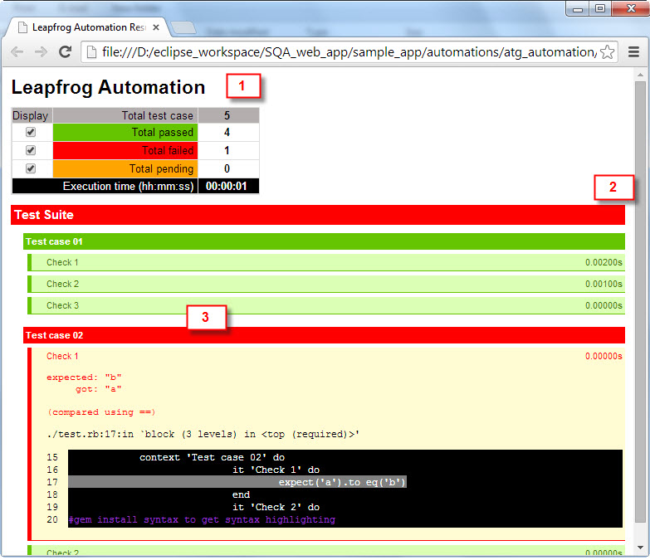

In this example, we edited report header, color, title … and changed status on test case/test suite to fail when having a failed check point.

1. Using customized report template

If you want to generate the rspec html report with customized template, you need to using 2 parameters in rspec command line are: --require (-r) and –format (-f) as below.

